**How to Attach an EBS Volume with an AWS EC2 Windows Instance**

Amazon EBS volumes provide a scalable storage service, which persists independently of the instance life. A user can attach an EBS volume to an EC2 instance. It is mandatory that both the volume as well as the instance be in the same availability zone. The user can assign a maximum of 16 EBS volumes to an instance.

A user has to specify the device name while attaching an EBS volume to an EC2 instance. When a volume is attached to a Windows instance, it is recommended to format the device and mount it as a drive.

1. Go to the AWS Console and select the EC2 Service. From the EC2 dashboard, Click on the ‘Running Instances’. Launch a Windows instance.

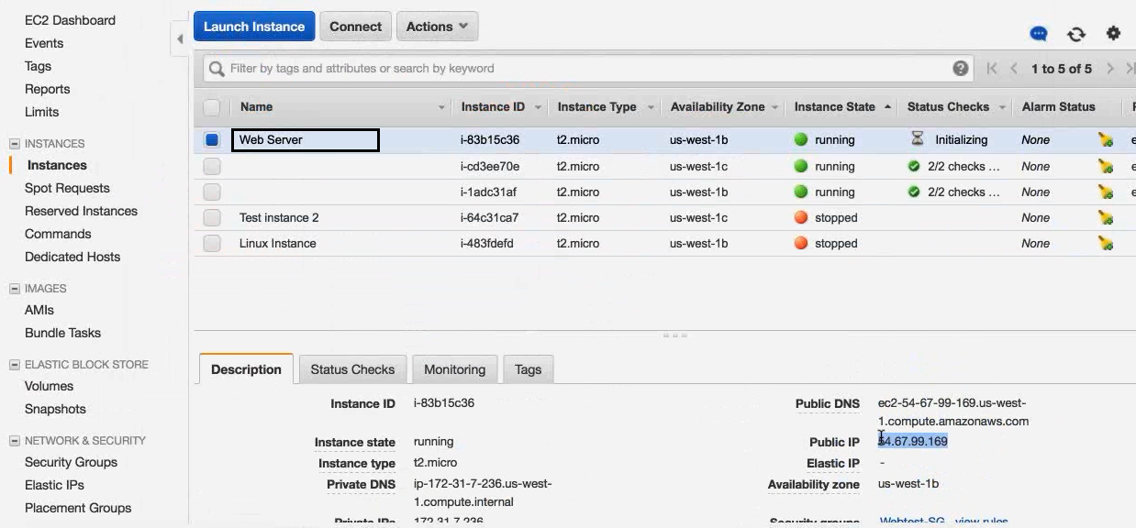

1. Go to Volumes and check the currently attached volume information. [Create an additional volume](http://www.newvem.com/ebs-how-to-create-or-delete-an-ebs-volume/) in the same zone where the instance is running.

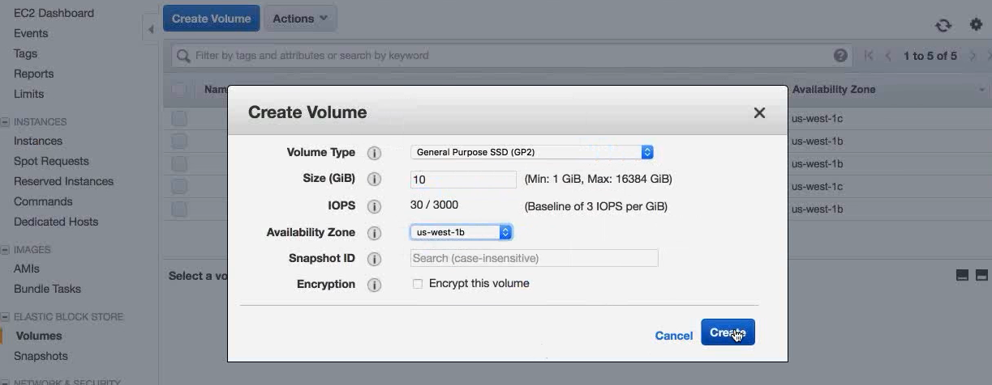

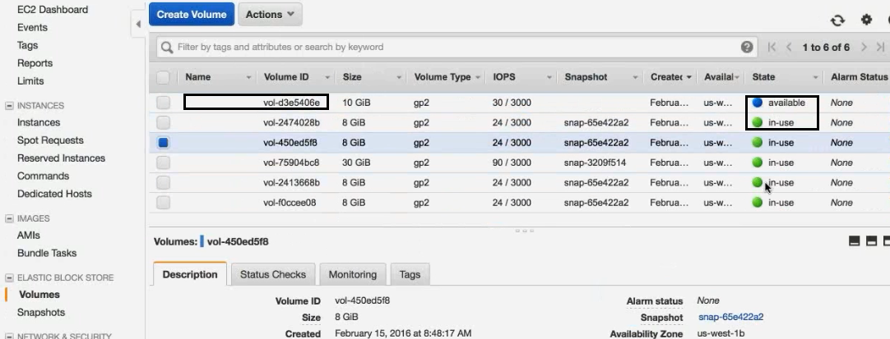

1. Select the volume to be attached. From the “Actions” menu, select “Attach Volume”.

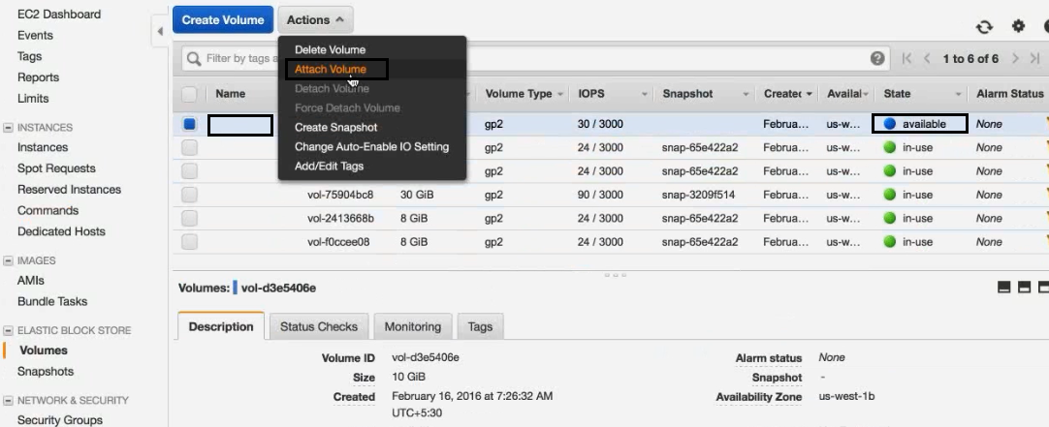

1. AWS will ask for the [EC2 instance,](http://www.newvem.com/aws/aws-getting-started-guide/connecting-to-your-amazon-ec2-instance/) where the EBS volume will be attached. The device name should also be provided. Click on “Attach”.

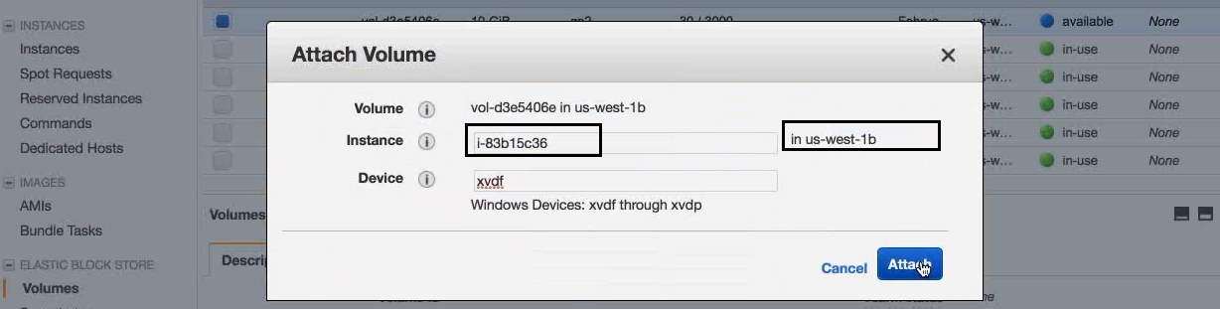

1. The volume will be attached to the instance and the instance information will be displayed in the volume attachment information.

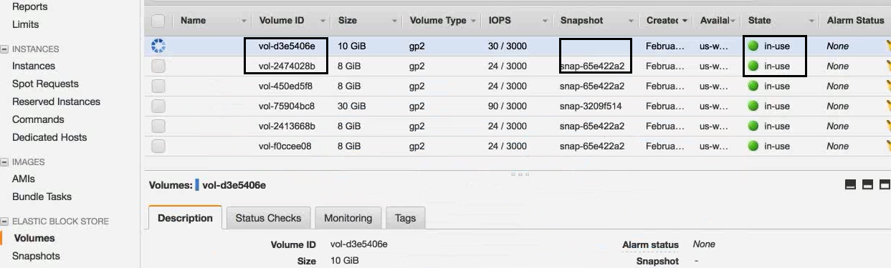

1. When the user checks the instance information, as explained in step#2, the two devices will be displayed. The newly attached device is shown as xvdf.

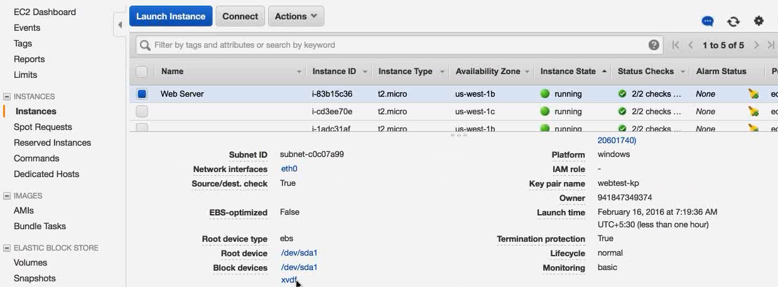

1. When the user clicks on the xvdf device, the device information will be displayed.
2. The user is required to [format the attached](http://www.newvem.com/how-to-format-an-aws-ebs-volume-attached-to-an-ec2-windows-instance/) device before using it.

The Amazon Elastic Block Store (Amazon EBS) offers persistent storage for the Amazon [EC2 instances.](https://www.newvem.com/cloudpedia/types-of-amazon-aws-ec2-instances/) We saw that an [EBS volume can be attached to AWS Windows instance](http://www.newvem.com/how-to-attach-a-volume-with-a-windows-instance-part-1) for vertical scalability.

This demonstrates how to format an EBS volume attached to a Windows instance:

1. Create an EBS volume and [attach it to Windows Instance.](http://www.newvem.com/how-to-attach-a-volume-with-a-windows-instance-part-1)
2. [Login to the Windows instance.](http://www.newvem.com/how-to-increase-the-root-disk-device-size-of-an-ebs-backed-windows-instance/) Currently only one disk drive (C Drive) is available in the instance. The new device (volume), which is mounted, is still not available in the instance.

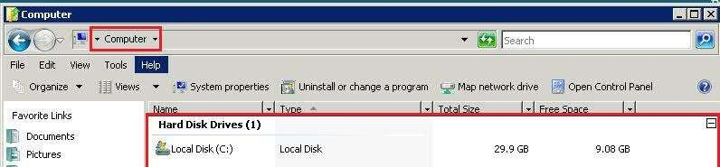

1. Go to the Control Panel -> Administrative Tools. Click on Computer Management. Click “Disk Storage”. If the new attached volume will be displayed as “Disk1”. It is still unallocated.

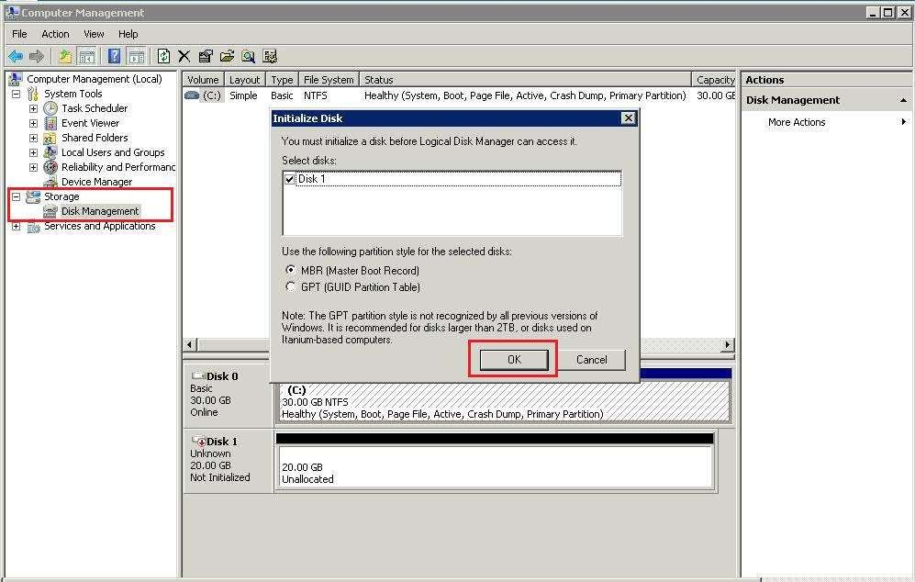

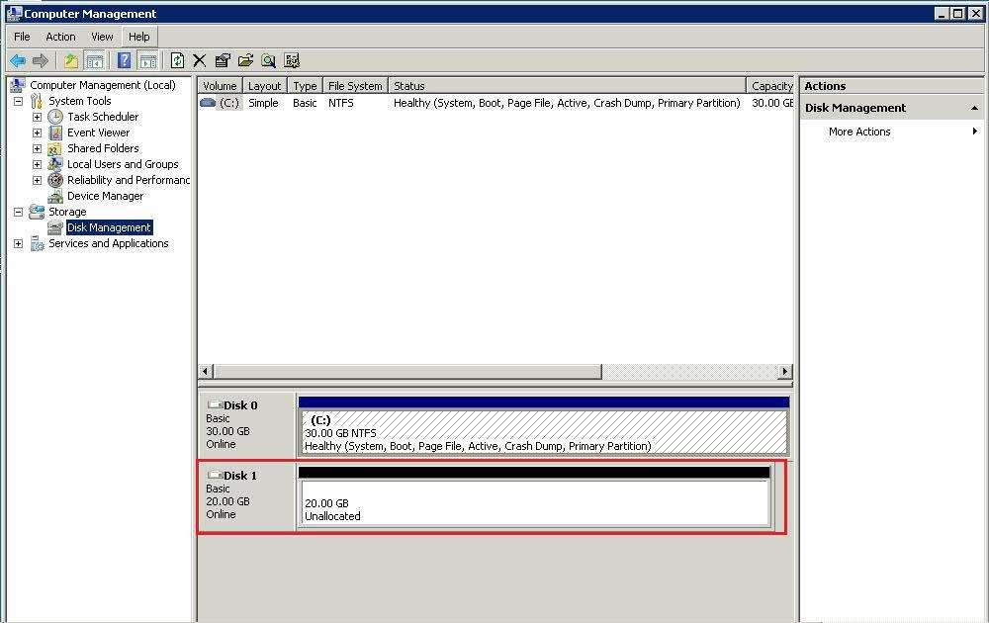

1. Right click on “Disk 1” and select “New Simple Volume”.

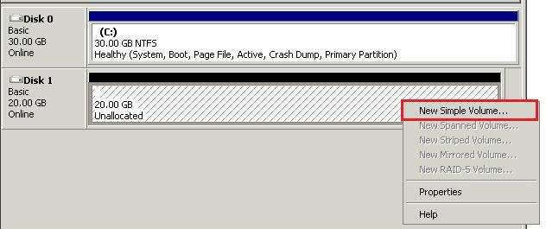

1. Windows will show the New Simple Volume Wizard. The user can select the default options or the options, such as the drive, and size as per requirement.

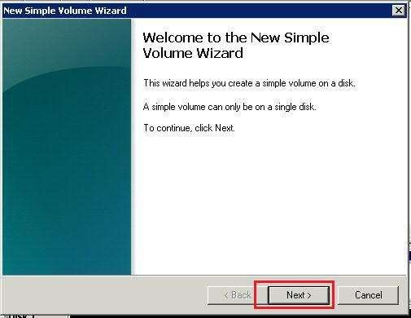

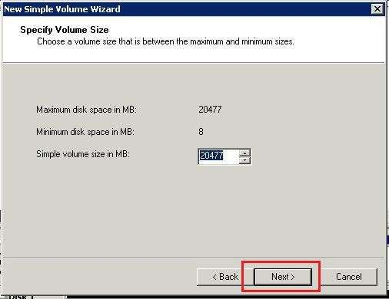

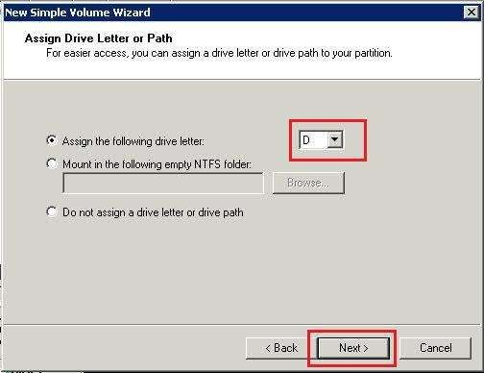

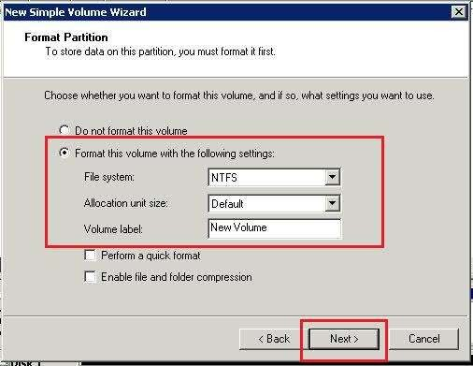

1. On completion of the above mentioned steps, the New Simple Volume Wizard will show the summary of all the steps for review. Click on the “Finish” button.

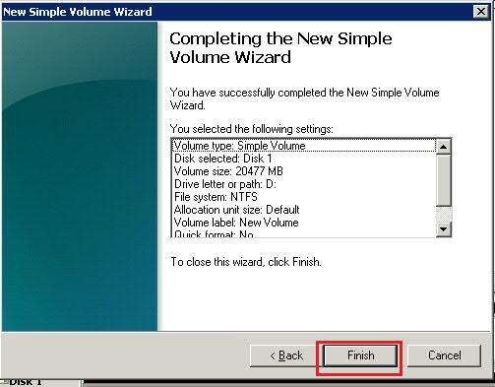

1. On completion of the above mentioned steps, the volume will be formatted.

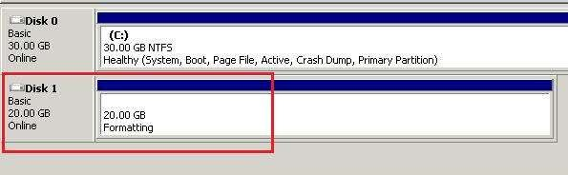

1. The new volume will be available after formatting as “D Drive”.

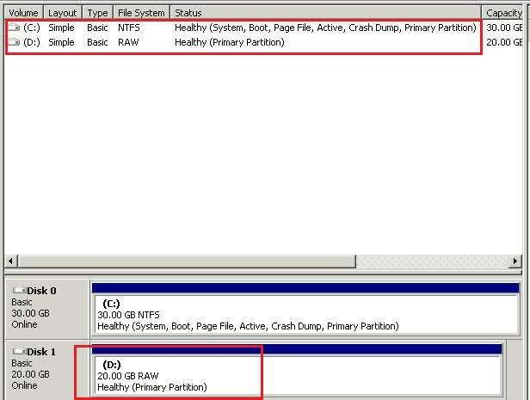

1. The new device will now be available in the computer.

